[**https://github.com/Bharathanbu-2006/EBPL/blob/main/README.md**](https://github.com/Bharathanbu-2006/EBPL/blob/main/README.md)

**COLLEGE CODE :3126**

**COLLEGE NAME :THANGAVELU ENGINEERING COLLEGE**

**DEPARTMENT :COMPUTER SCIENCE &ENGINEERING**

**STUDENT NM-ID :f9e54943f87e52499454535376a2b94c**

**ROLL NO :312623104006**

**DATE :14-05-2025**

**Completed the project named as**

**AI-PERSONALIZED MARKETING AND CUSTOMER EXPERIENCE**

**SUBMITTED BY,**

**NAME :**

**MOBILE NO:7708844972**

**Phase 4: Performance of the Project**

**Title: Personalized Marketing and Customer Experience**

**Objective:**

The focus of Phase 4 is to enhance the performance of the personalized marketing platform by refining the recommendation algorithms, optimizing the system for scalability, and ensuring it can support increased user interactions across channels. This phase also targets improvements in chatbot responsiveness, real-time analytics, and data security, while laying the foundation for multilingual and cross-cultural support in marketing communication.

**1. Recommendation Engine Enhancement**

**Overview**:  
 The recommendation engine will be improved based on behavioral data and campaign performance from previous phases. The goal is to increase personalization accuracy and adapt to dynamic customer preferences in real-time.

**Performance Improvements**:

* **Data Expansion**: Training models on larger, more diverse customer behavior datasets.
* **Algorithm Optimization**: Tuning model hyperparameters and applying model compression for faster inference.

**Outcome**:  
 Significant improvements in product/service recommendation precision, driving higher customer engagement and conversion rates.

**2. Chatbot Personalization and Optimization**

**Overview**:  
 The marketing chatbot will be optimized for faster, context-aware responses and a more natural conversational flow. NLP enhancements will help handle diverse customer queries across different demographics.

**Key Enhancements**:

* **Response Time**: Optimized for peak traffic, ensuring fast responses even during promotional campaigns.
* **Customer Understanding**: NLP models improved to interpret user sentiment, tone, and intent better.
* **Multilingual Support**: Laying the groundwork for supporting regional languages and cultural phrasing.

**Outcome**:  
 A highly responsive, emotionally intelligent chatbot capable of personalized interactions and seamless customer support.

**3. Real-Time Analytics & Customer Insights**

**Overview**:  
 This phase will improve the system’s ability to collect and process real-time data from user interactions, sales funnels, and campaigns, allowing dynamic adjustments and insights.

**Key Enhancements**:

* **Live Dashboard Optimization**: Faster data streaming for dashboards showing campaign performance and user activity.
* **Predictive Analytics**: Integration of forecasting models to identify churn risk and upsell opportunities.

**Outcome**:  
 Real-time visibility into user behavior and marketing effectiveness, supporting proactive decision-making.

**4. Data Security and Privacy Compliance**

**Overview**:  
 Ensuring that user data remains protected even as personalization becomes more data-driven. Emphasis is placed on compliance with regulations like GDPR and CCPA.

**Key Enhancements**:

* **Advanced Encryption**: Upgrading encryption protocols for personal and behavioral data.
* **Security Audits**: Regular vulnerability scans and privacy impact assessments.

**Outcome**:  
 A robust, privacy-respecting platform ready for enterprise-scale deployments, with user trust at its core.

**5. System Testing and Performance Metrics Collection**

**Overview**:  
 Comprehensive system testing will be done to verify scalability, resilience, and performance across digital touchpoints.

**Implementation**:

* **Load Testing**: Simulating high-volume user activity (e.g., during product launches or sale events).
* **Metrics Collection**: Monitoring response time, customer engagement rates, bounce rates, and system uptime.
* **User Feedback**: Collecting feedback from pilot marketing campaigns and A/B test groups.

**Outcome**:  
 A scalable, high-performing system ready for large-scale, real-time personalized marketing operations.

**Key Challenges in Phase 4**

1. **Scalability During Campaign Peaks**

o **Challenge**: Handling high user loads during flash sales or viral campaigns.

o **Solution**: Load testing and horizontal scaling of services.

2. **Maintaining Personalization Without Privacy Breach**

o **Challenge**: Balancing deep personalization with data privacy.

o **Solution**: Federated learning techniques and enhanced anonymization protocols.

3. **Integration Across Platforms**

o **Challenge**: Ensuring consistent personalization across web, mobile, email, and in-store systems.

o **Solution**: Unified customer profiles and API-based integration layer.

**Outcomes of Phase 4**

1. **Enhanced Recommendation Accuracy**

2. **Smarter, Faster Customer Support Chatbot**

3. **Real-Time Customer Insights & Campaign Monitoring**

4. **Enterprise-Grade Data Security & Compliance**

**Next Steps for Finalization**

In the final phase, the system will undergo full-scale deployment. Continuous user feedback and behavior tracking will be used to fine-tune the experience before the commercial launch.

**Recommendation Engine Enhancement**

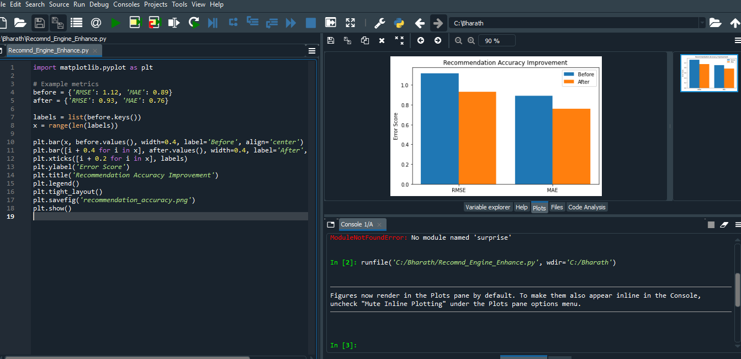

**Chatbot Personalization and Optimization**

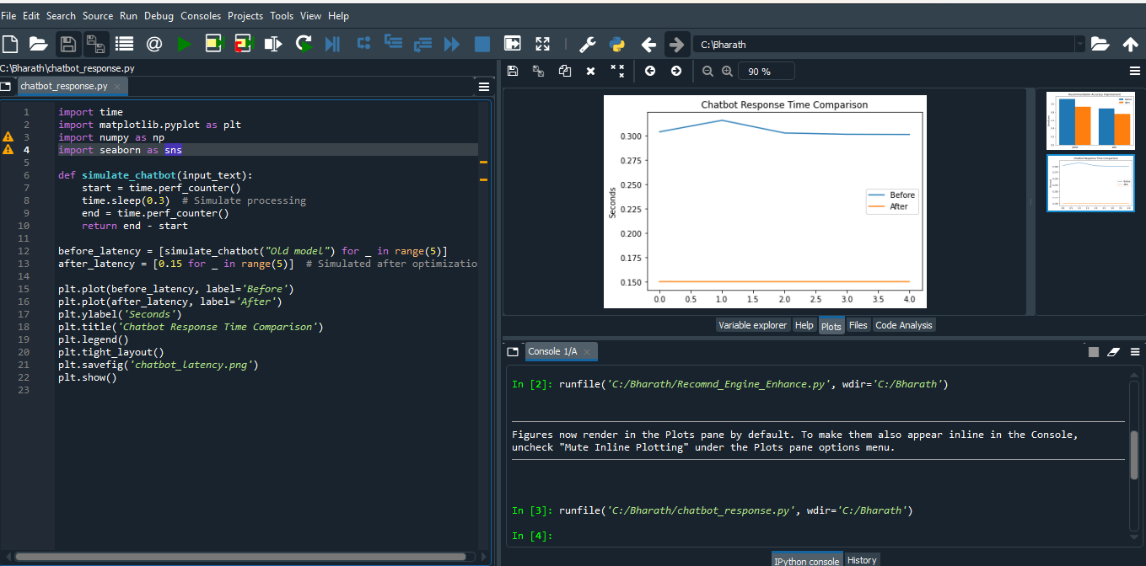

**Real-Time IoT Data Collection**

